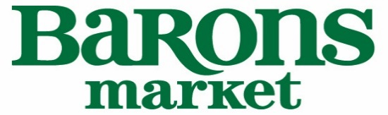

Barons Market Demo & Ad Program

At Barons Market, we believe that the best way to introduce a customer to a new product, is by tasting it. We’ve designed our stores to provide our customers with an engaging, exciting, warm and unique customer experience, and an integral part of our in-store experience, is our demo station. Our demo staff is made up of people that love food and love people. Our staff will not only sample your product but will talk about your product to our customers, specifically about what makes it unique. We’ve set up a successful demo program that includes:

- Live demos in all 9 of our stores, 8 hours a day, 7 days a week.
- We charge $100 per demo (8 hours live), per store and $50 per ad, per store.
- The total for a live demo in all 9 of our stores plus a weekly ad is $900 + $450 = $1350.
- Our weekly ad is available on our website for a duration of one week.
- Depending on the product, we will also feature it on our Instagram page the week of the demo and ad.

We recommend monthly or quarterly demos as it really gives our customers an opportunity to taste the product a few times which encourages repeat purchases.

For more information or to schedule a demo and/or an ad, please contact:

Carmen Ring
Demo Coordinator
Barons Market

Home Office
12420 Kirkham Court
Poway, CA 92064
Tel: 858.218.2100 ext. 105
Fax: 858.218.2477
CarmenRing@baronsmarket.com

